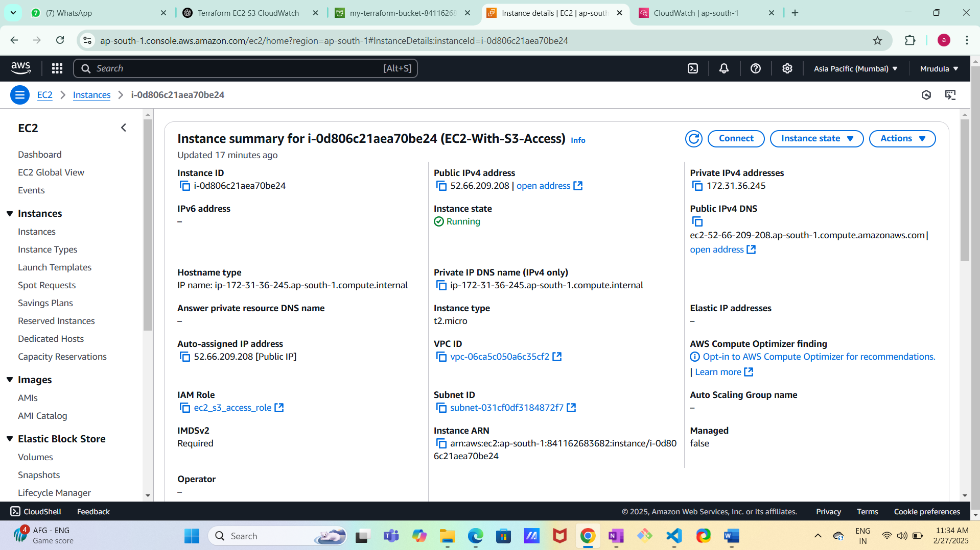

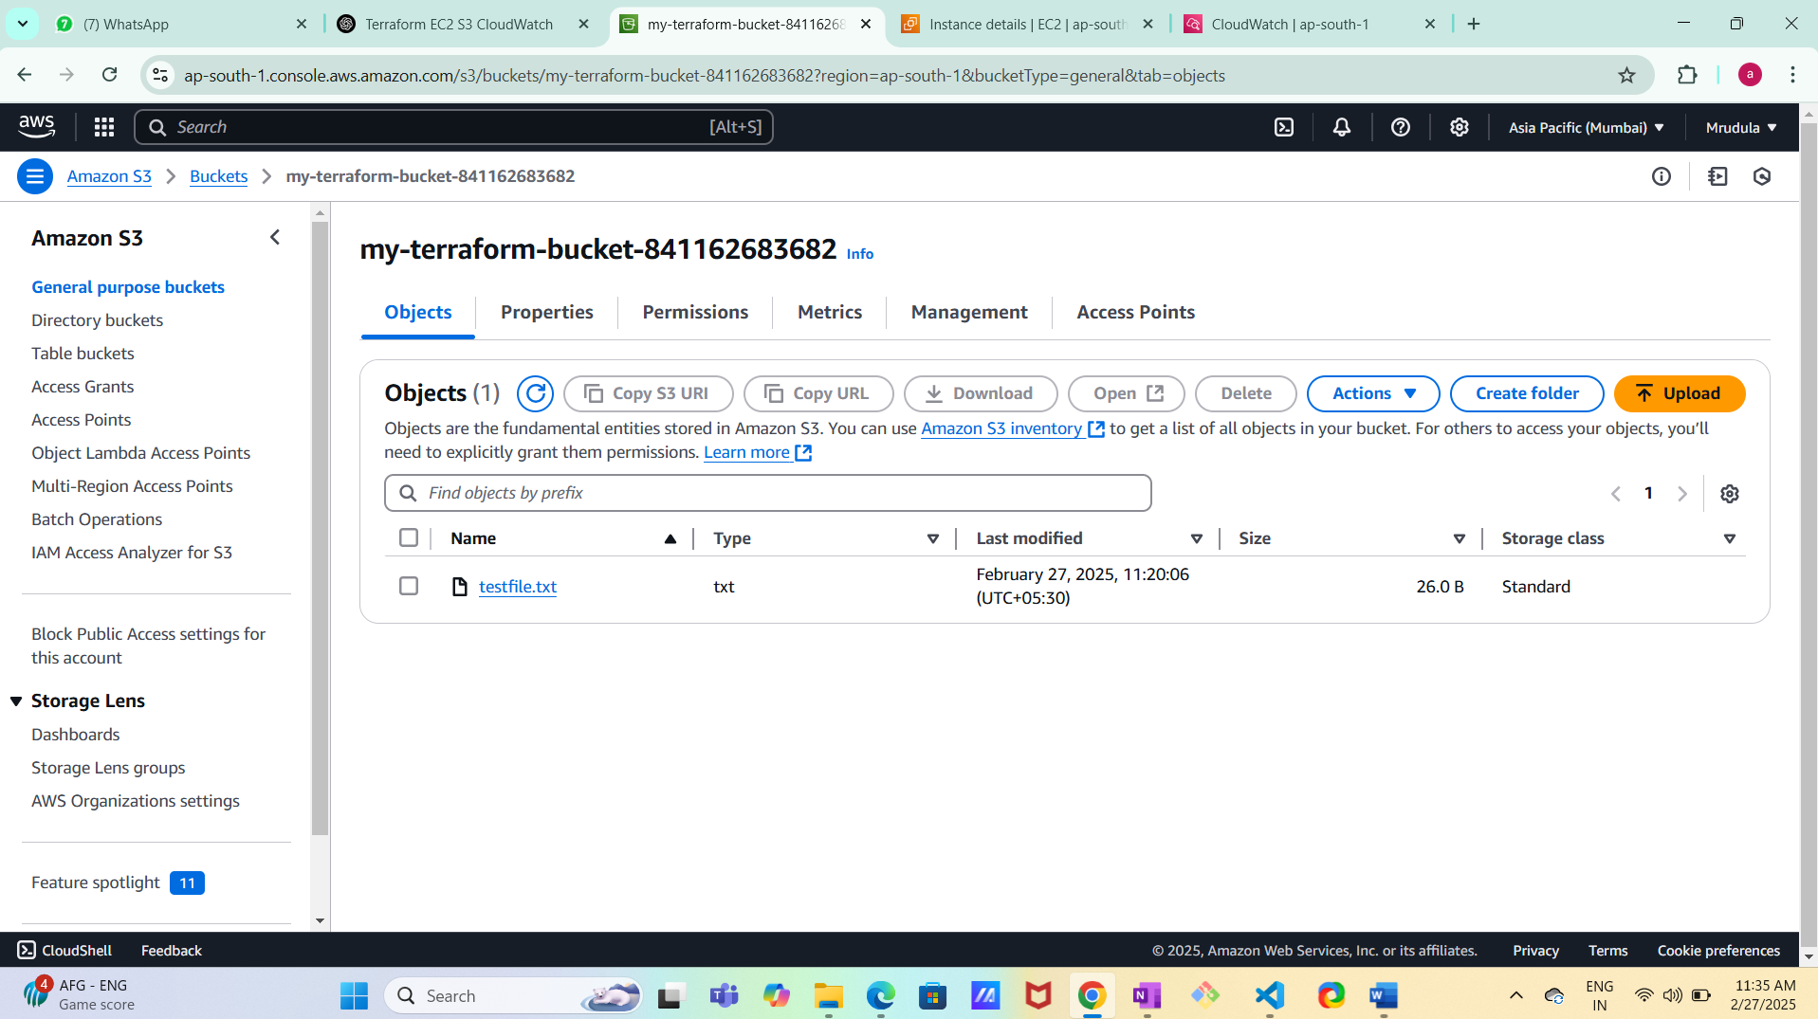

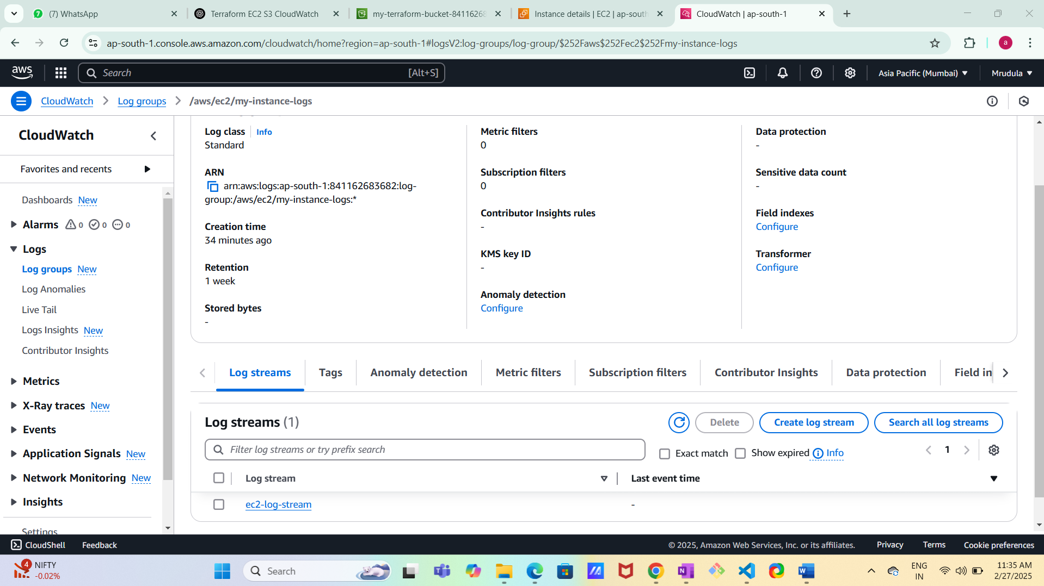

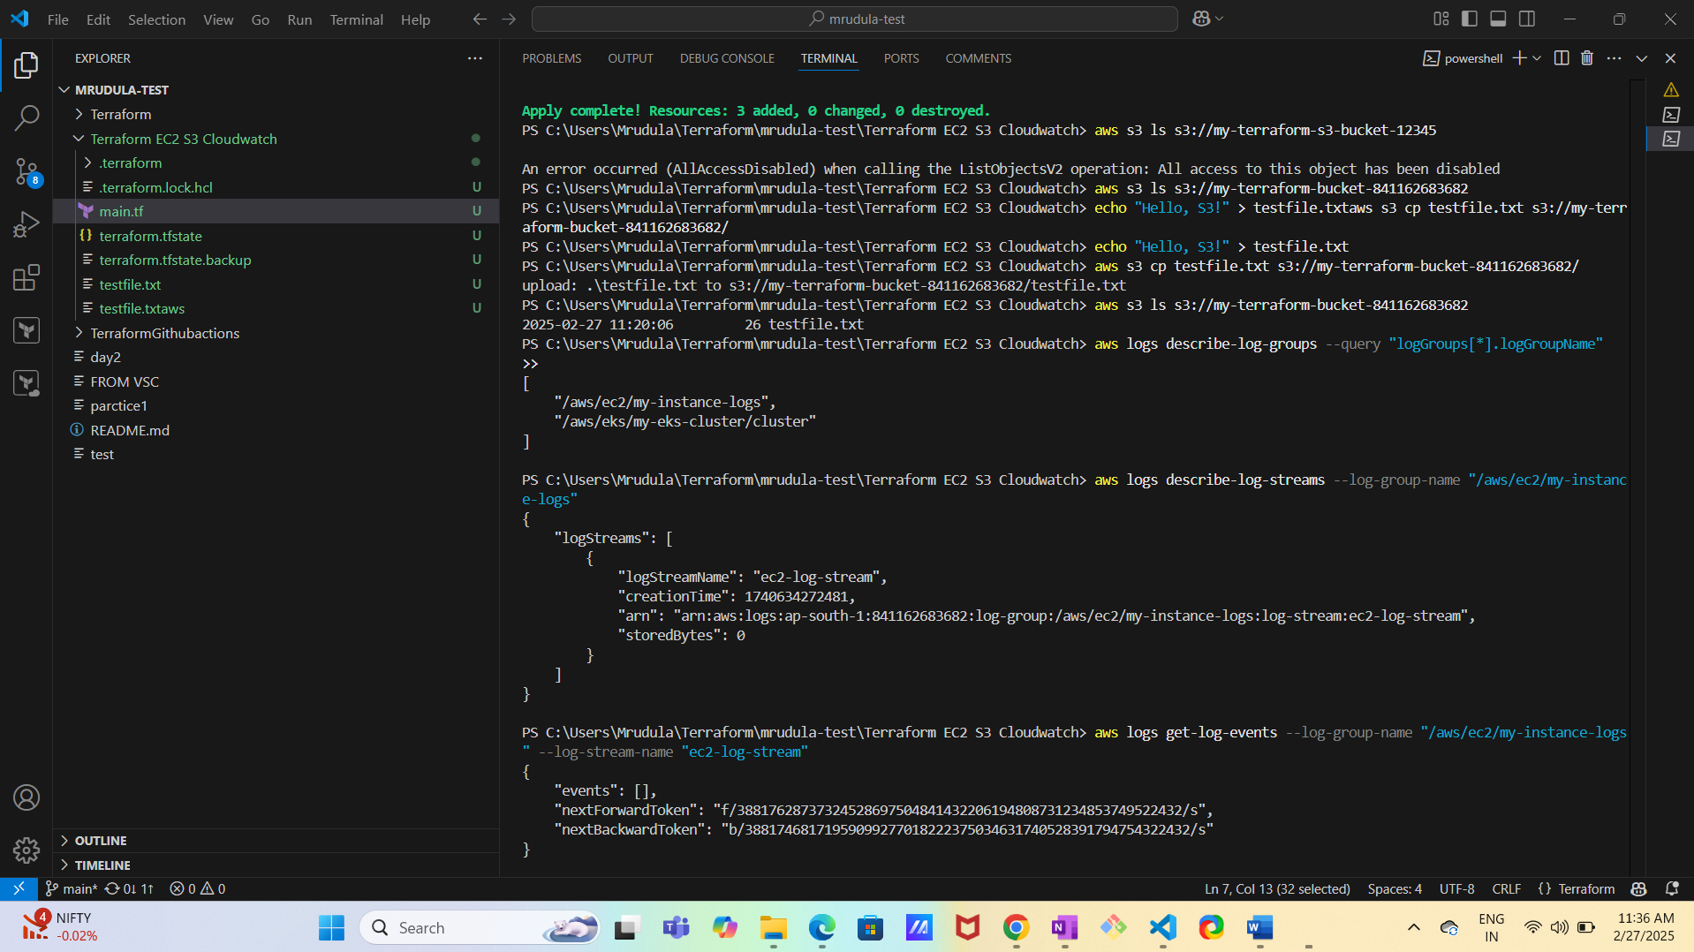

**Terraform main.tf**

provider "aws" {

  region = "ap-south-1" # Change as needed

}

# Create an S3 bucket

resource "aws_s3_bucket" "my_bucket" {

  bucket = "my-terraform-bucket-841162683682"# Change to a unique name

}

# IAM Role for EC2 to access S3

resource "aws_iam_role" "ec2_role" {

  name = "ec2_s3_access_role"

  assume_role_policy = jsonencode({

    Version = "2012-10-17"

    Statement = [

      {

        Action = "sts:AssumeRole"

        Effect = "Allow"

        Principal = {

          Service = "ec2.amazonaws.com"

        }

      }

    ]

  })

}

# IAM Policy for S3 Access

resource "aws_iam_policy" "s3_policy" {

  name        = "s3_access_policy"

  description = "Allows EC2 to access S3"

  policy = jsonencode({

    Version = "2012-10-17"

    Statement = [

      {

        Action = [

          "s3:GetObject",

          "s3:ListBucket",

          "s3:PutObject"

        ]

        Effect   = "Allow"

        Resource = [

          aws_s3_bucket.my_bucket.arn,

          "${aws_s3_bucket.my_bucket.arn}/*"

        ]

      }

    ]

  })

}

# Attach Policy to Role

resource "aws_iam_role_policy_attachment" "s3_attachment" {

  role       = aws_iam_role.ec2_role.name

  policy_arn = aws_iam_policy.s3_policy.arn

}

# IAM Instance Profile

resource "aws_iam_instance_profile" "ec2_profile" {

  name = "ec2_instance_profile"

  role = aws_iam_role.ec2_role.name

}

# Create EC2 Instance

resource "aws_instance" "my_instance" {

  ami           = "ami-0ddfba243cbee3768" # Change to latest Amazon Linux 2 AMI

  instance_type = "t2.micro"

  iam_instance_profile = aws_iam_instance_profile.ec2_profile.name

  tags = {

    Name = "EC2-With-S3-Access"

  }

}

# Create CloudWatch Log Group

resource "aws_cloudwatch_log_group" "ec2_log_group" {

  name              = "/aws/ec2/my-instance-logs"

  retention_in_days = 7

}

# Create CloudWatch Log Stream

resource "aws_cloudwatch_log_stream" "ec2_log_stream" {

  name           = "ec2-log-stream"

  log_group_name = aws_cloudwatch_log_group.ec2_log_group.name

}

# IAM Policy for CloudWatch Logs

resource "aws_iam_policy" "cloudwatch_policy" {

  name        = "cloudwatch_logs_policy"

  description = "Allows EC2 to write logs to CloudWatch"

  policy = jsonencode({

    Version = "2012-10-17"

    Statement = [

      {

        Action = [

          "logs:CreateLogStream",

          "logs:PutLogEvents"

        ]

        Effect   = "Allow"

        Resource = "${aws_cloudwatch_log_group.ec2_log_group.arn}:*"

      }

    ]

  })

}

# Attach CloudWatch Policy to EC2 Role

resource "aws_iam_role_policy_attachment" "cloudwatch_attachment" {

  role       = aws_iam_role.ec2_role.name

  policy_arn = aws_iam_policy.cloudwatch_policy.arn

}